1. Tuple with 10 Elements:
t = (10, 5.5, "apple", 20, "banana", 8.2, 15, "grape", 7.0, "orange")
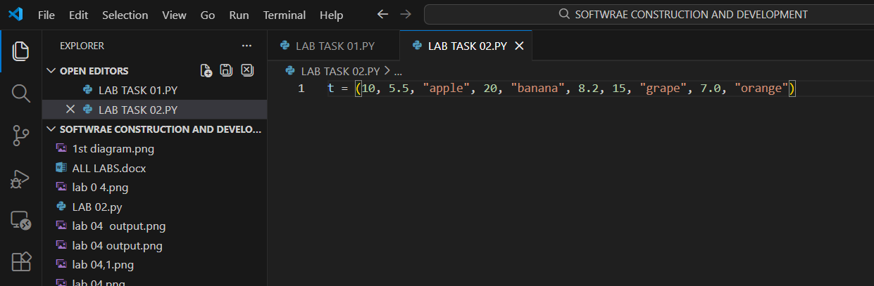

2. Count Specific Element:
my_touple = (1, 2, 3, 2, 4, 2, 5 )
element = 2
count = my_touple.count(element)
print(f"The element{element} appears {count} times in the touple.")
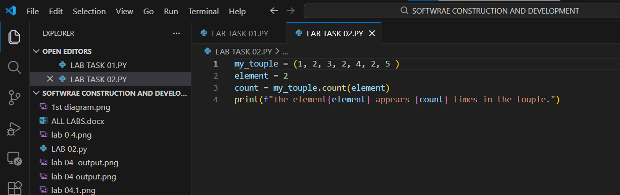

Output:
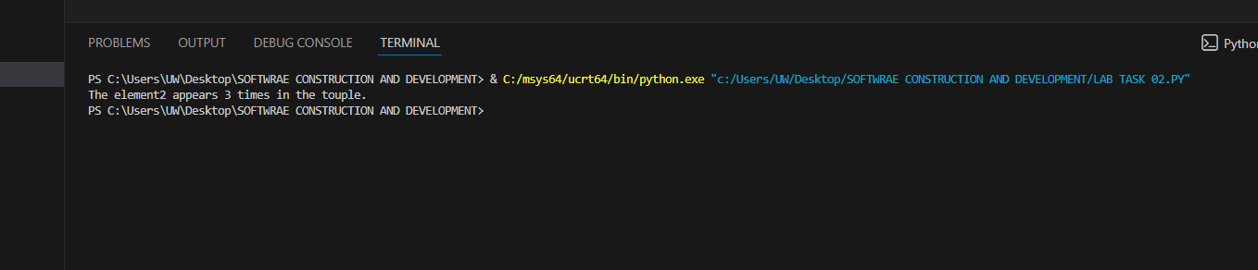

3. Tuple → List → Modify → Tuple
t = (1, 2, 3)
lst = list(t)
lst.append(4)
t = tuple(lst)
print(t)
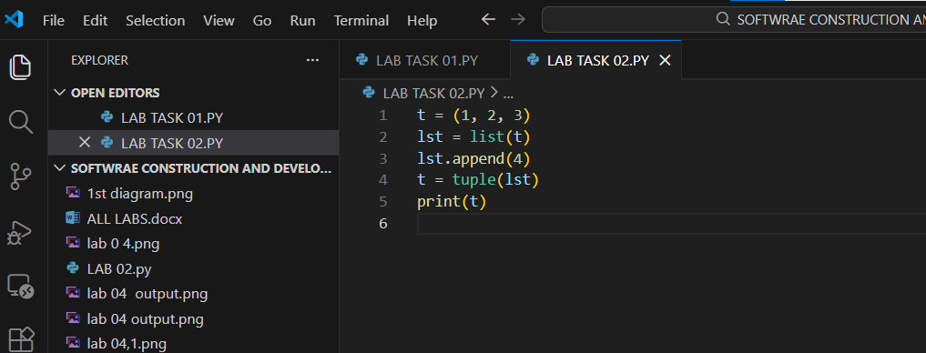

Output:
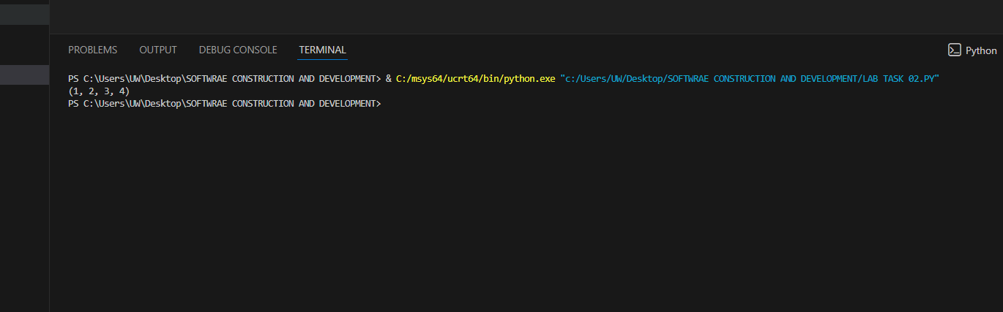

4. Nested Tuple Access:
nested = (1, 2, (10, 20, 30), 4)
print(nested[2][1]) # Output: 20
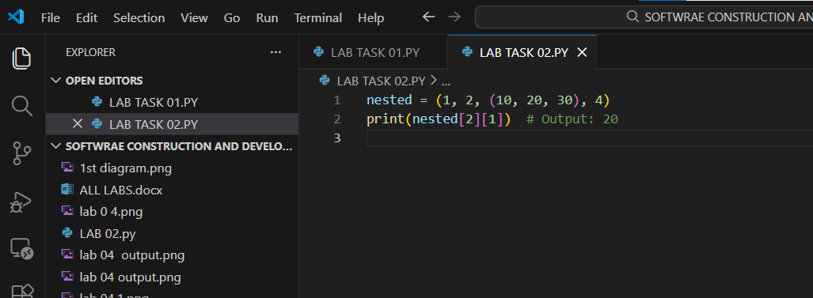

Output:
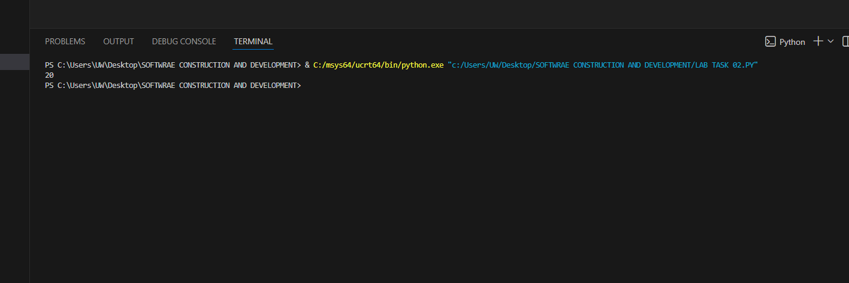

5. Define Set of 7 Elements:
s = {1, 2.5, "apple", 3, 7.2, "banana", 10}
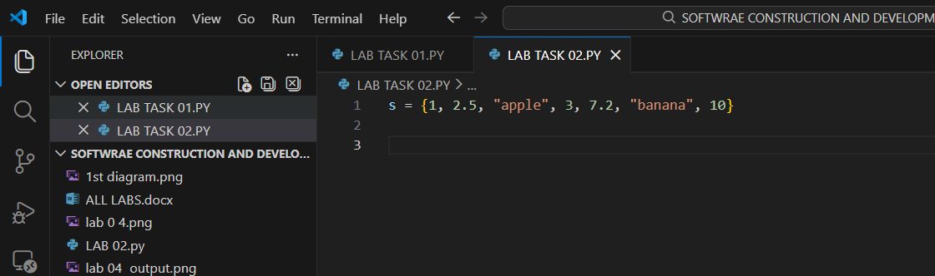

6. Add and Update Set:
my_set = {1, 2.5, "apple", 4, "banana"}
my_set.add("grape")
my_set.update([6, 7.5, "orange"])
print("Update set: ", my_set)
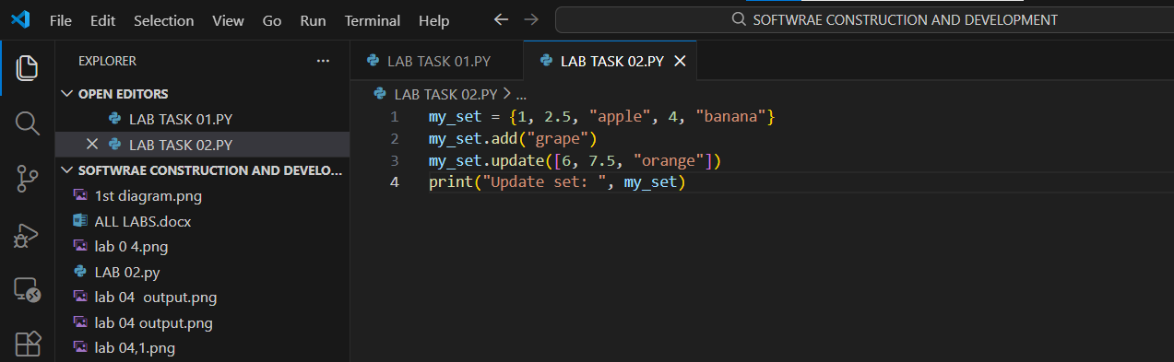

Output:
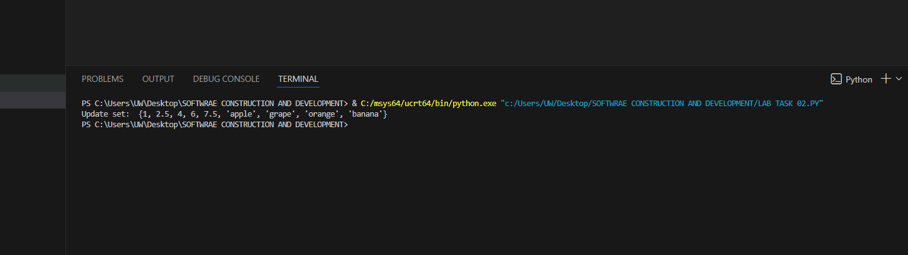

7. Remove Elements from Set
my_set = {10, 20, 30, 40, 50}
my_set.remove(30)
my_set.discard(40)
print("Updated set:", my_set)
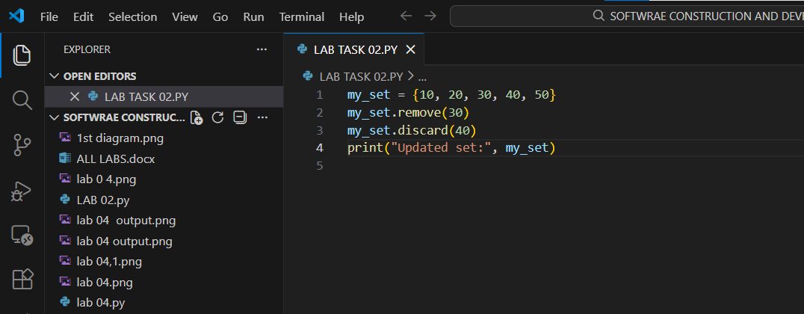

Output:
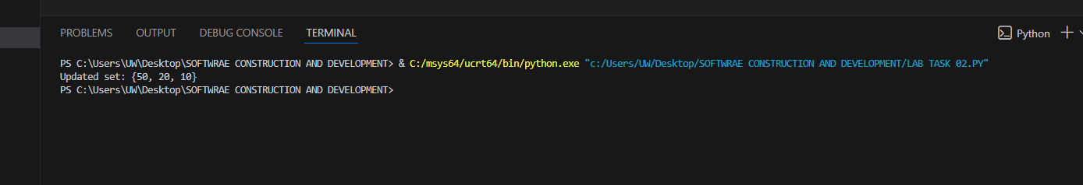

8. Union of Sets:
a = {1, 2, 3}
b = {3, 4, 5}
print(a.union(b))
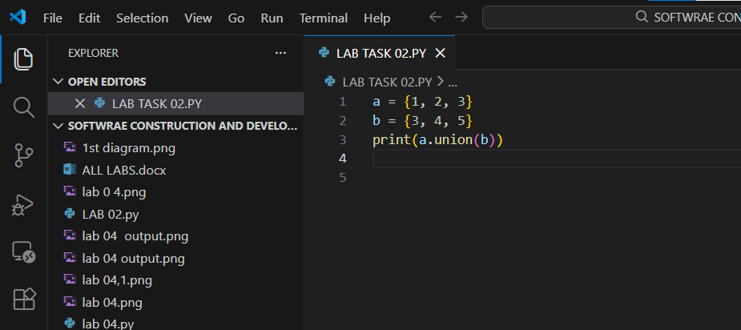

Output:
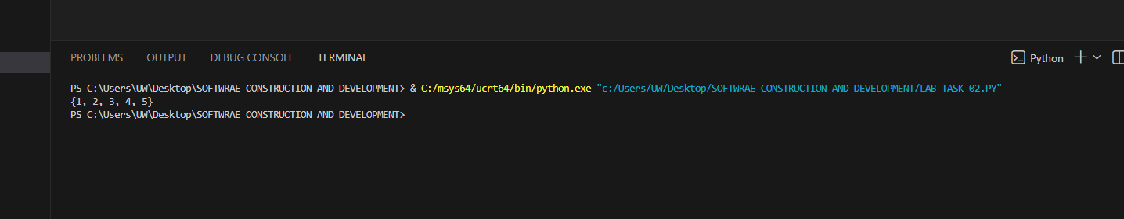

9. Intersection of Sets:
set1 = {1, 2, 3, 4}
set2 = {3, 4, 5, 6}
intersection = set1.intersection(set2)
print("Intersection: ", intersection)
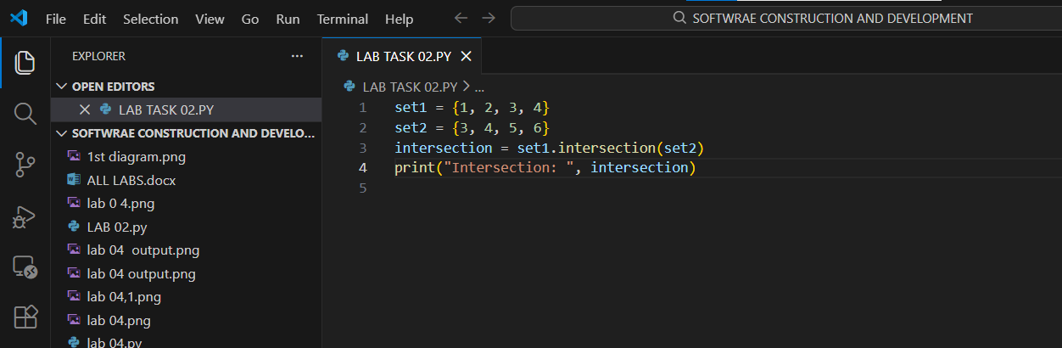

Output:
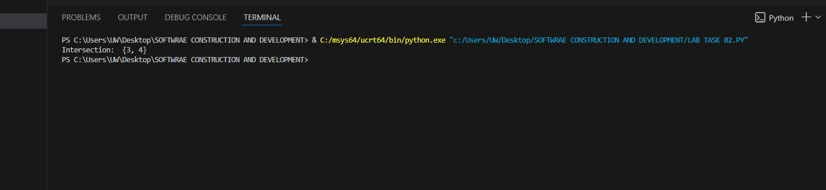

10. Dictionary of Students:
students = {"Ali": 85, "Sara": 90, "Usman": 78}
for name, marks in students.items():
print(name, ":", marks)
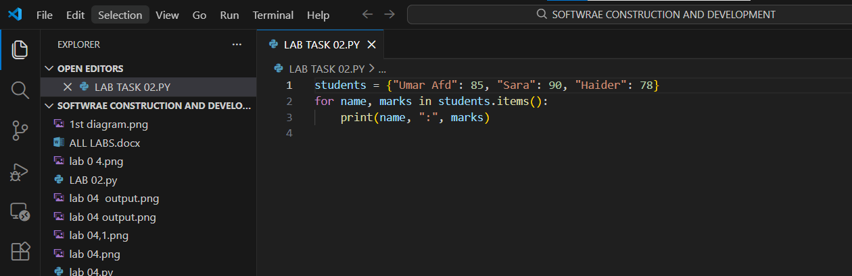

Output:
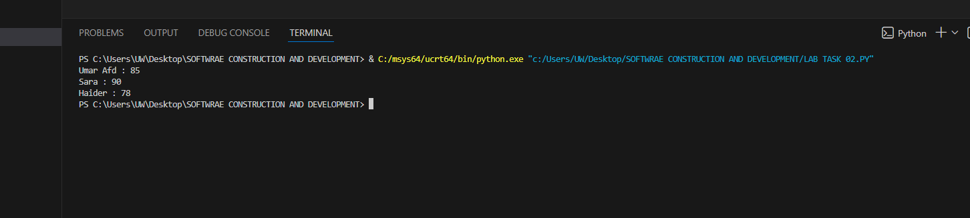

11. Add New Key-Value Pair:
students = {"Umar": 85, "Kashif": 90, "Haider": 78}
students["Ayesha"] = 88
print(students)
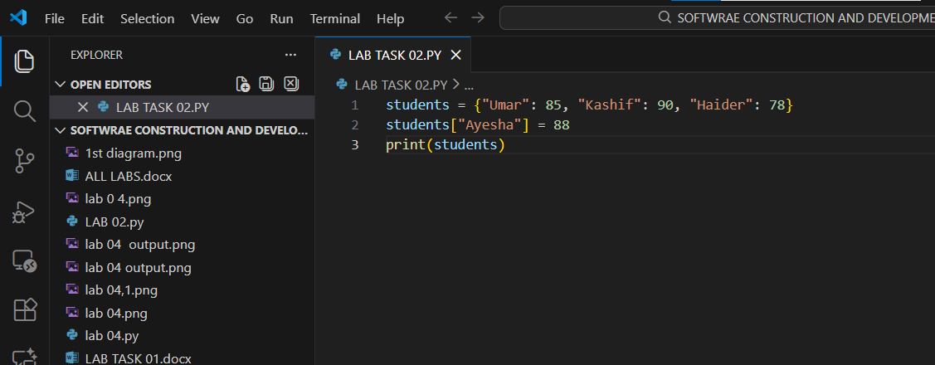

Output:
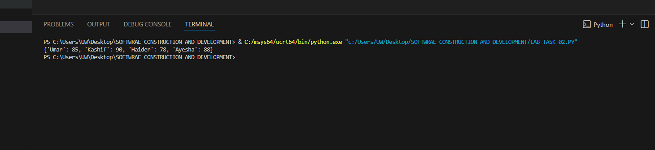

12. Access Value by Key:
students = {"Ali": 85, "Sara": 90, "Usman": 78}
print(students["Sara"])
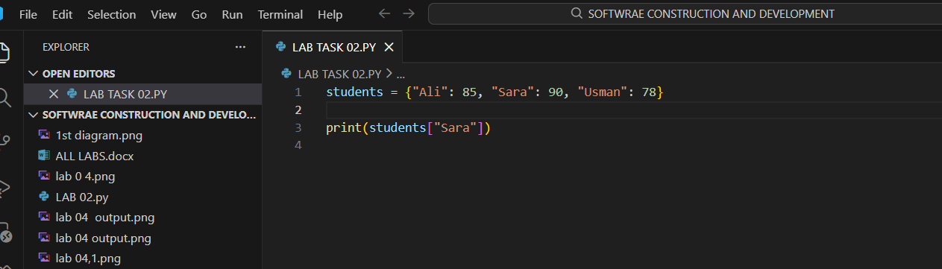

Output:
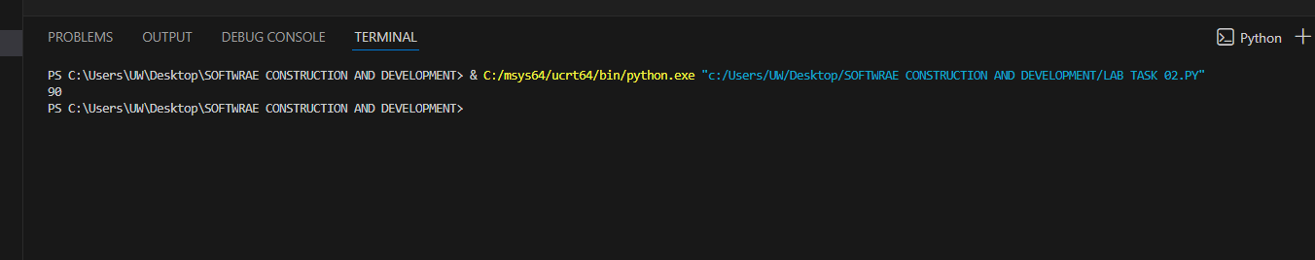

13. Add Key-Value Using Assignment:
students = {"Ali": 85, "Sara": 90, "Usman": 78}
students["Bilal"] = 92
print(students)

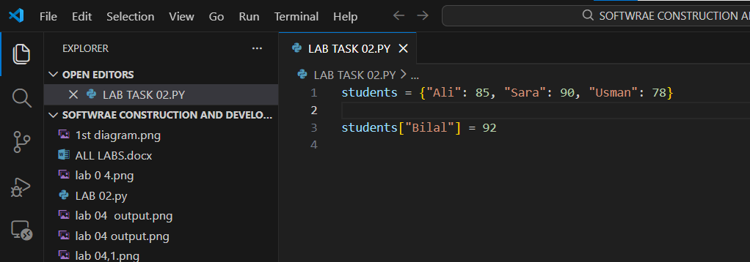

Output:
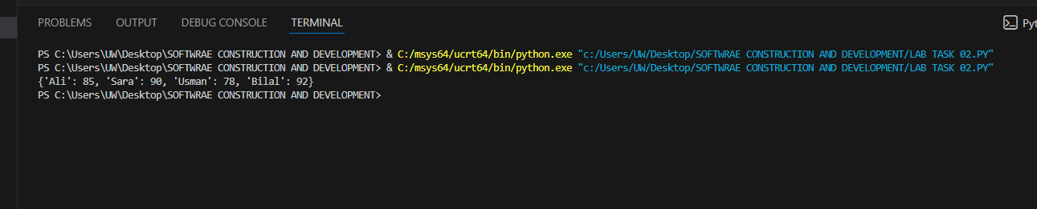

14. Update Existing Value:
students = {"Ali": 85, "Sara": 90, "Usman": 78}
students["Sara"] = 95
print(students)
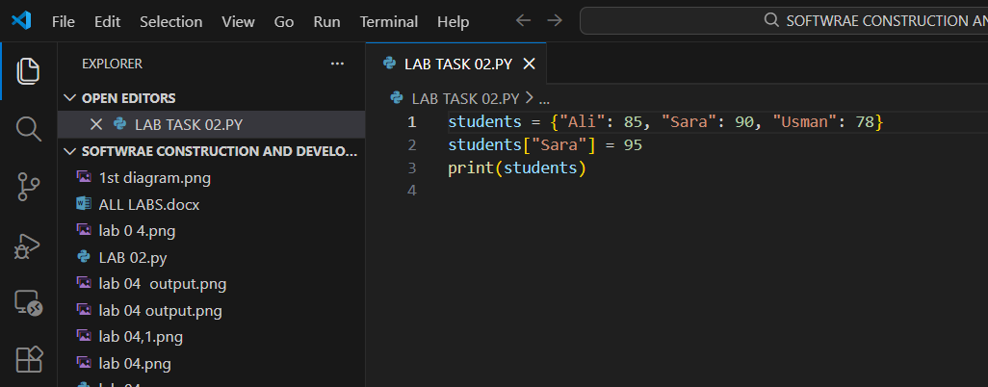

Output:
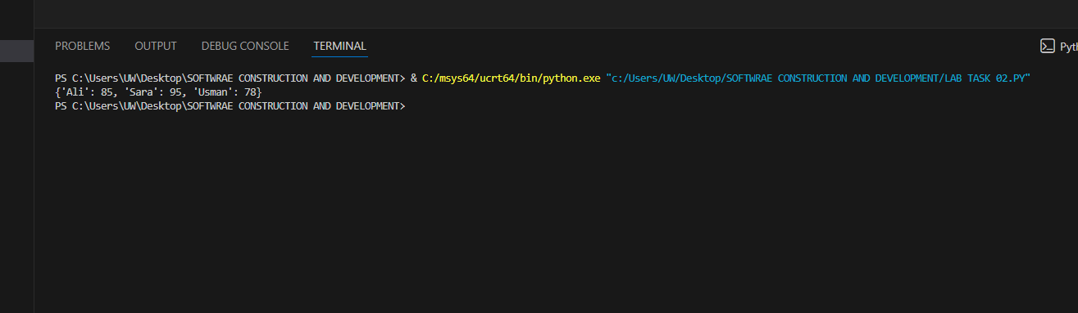

15. Remove with `pop()` and `del`:
students = {"Ali": 85, "Sara": 90, "Usman": 78}
students.pop("Ali")
del students["Usman"]
print(students)
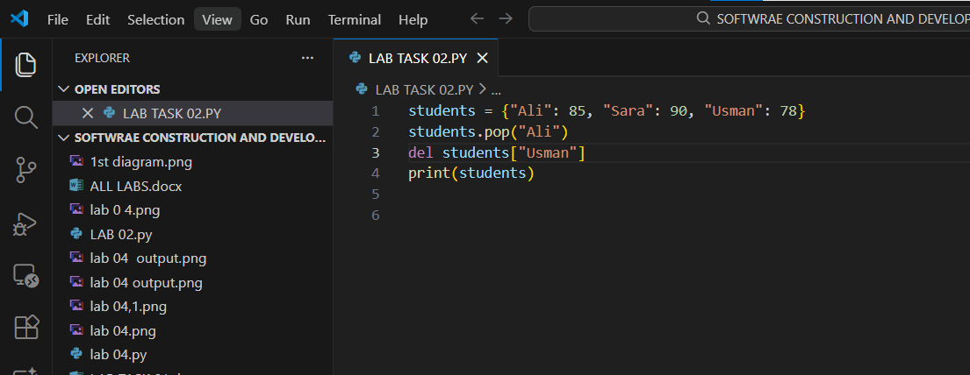

Output:
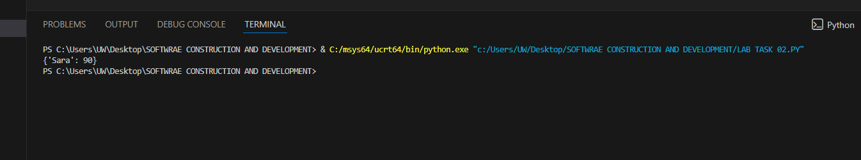

16. Loop with `.items()`
students = {"Ali": 85, "Sara": 90, "Usman": 78}
for key, value in students.items():
print(key, ":", value)
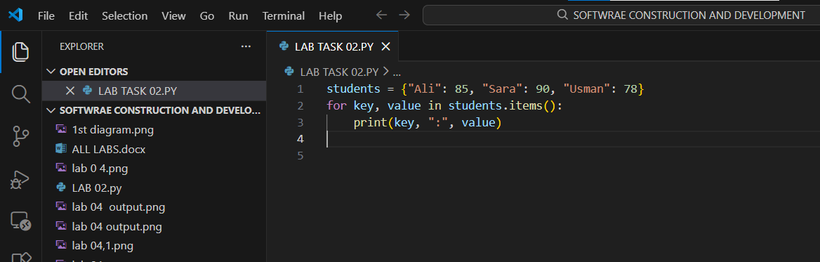

Output:
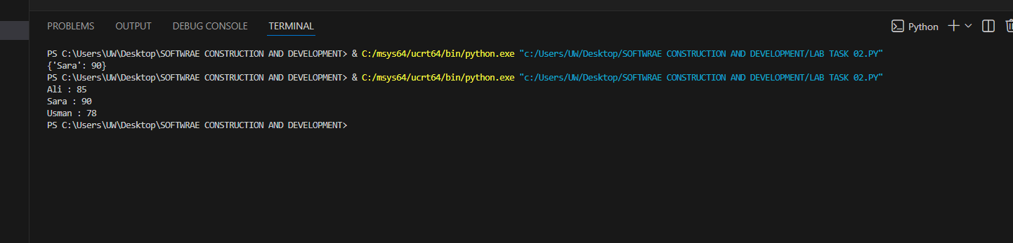

17. Number of Items:
students = {"Ali": 85, "Sara": 90, "Usman": 78}
print(len(students))
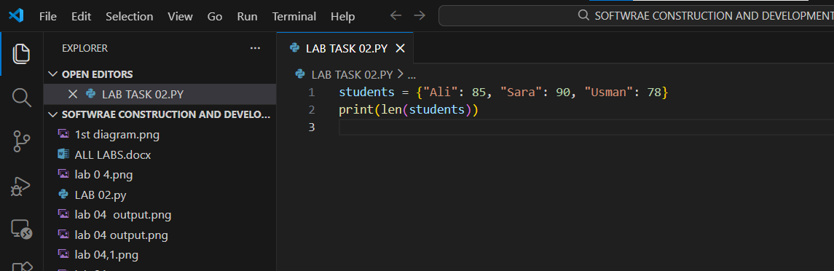

Output:
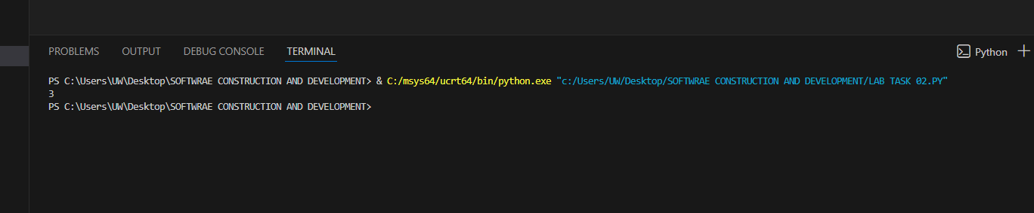

18. Merge Dictionaries:
dict1 = {"a": 1, "b": 2}
dict2 = {"c": 3, "d": 4}
dict1.update(dict2)
print(dict1)
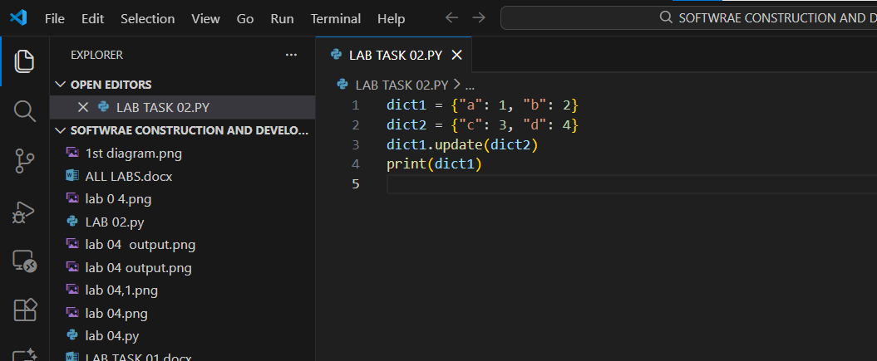

Output:
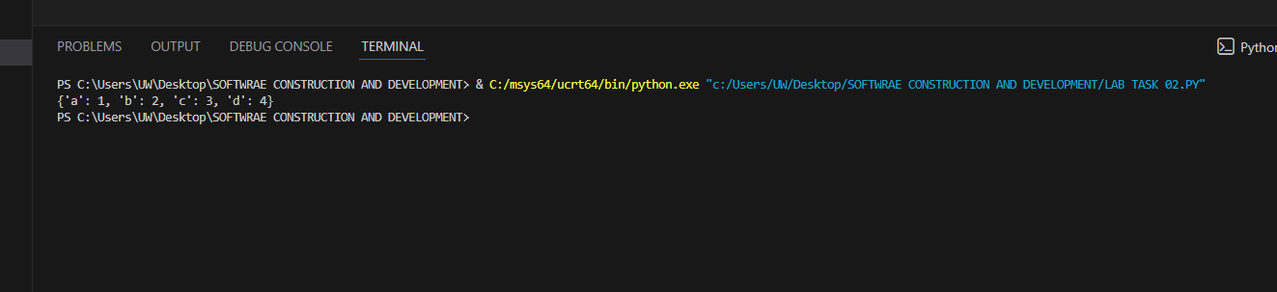

END

